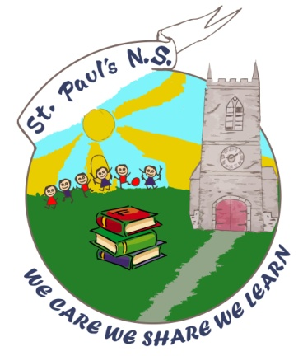 School Calendar 2023-2024
www.stpaulscollooney.com
St.Paul's N.S., Collooney, Co.Sligo | stpaulscollooney@gmail.com | 071-9130491
St. Paul's National School

School

August Thursday 31st school reopens

October School closing on Friday 27th October at 12noon mid-term break,
re-opens 6th November

December School closed on Friday 22nd December @ 12noon, re-opens Monday
8th January 2023

February 2024 School closed Monday 5th February – Public Holiday

School closed Thursday 15th & Friday 16th February - midterm
School re-opens on Monday 19th February

March/April School closed Monday 18th March
Easter Holidays School closes Friday 22nd March @ 12noon and re-opens Monday 8th April

May Monday 6th May, Bank Holiday – School closed & Tuesday 7th May.

June Monday 3rd June – Bank Holiday – School Closed

School closes @ 12noon Tuesday 25th June for summer holidays

